**Education Project Report**

**Description:**

GUI Application using Java that connect Instructors and Students together such as LMS. Each Instructor manage specific course, instructor can add content to the course, add exams to the courses and search for student by his ID to show all his information (Name, Registered Courses, Grades in each course, GPA). Secondly student can register in the courses then show its content and finally take exams and system will compute his grade in the exam and Total Grade (GPA).

**Project Component:**

**Development**

**1-Main Frame:**

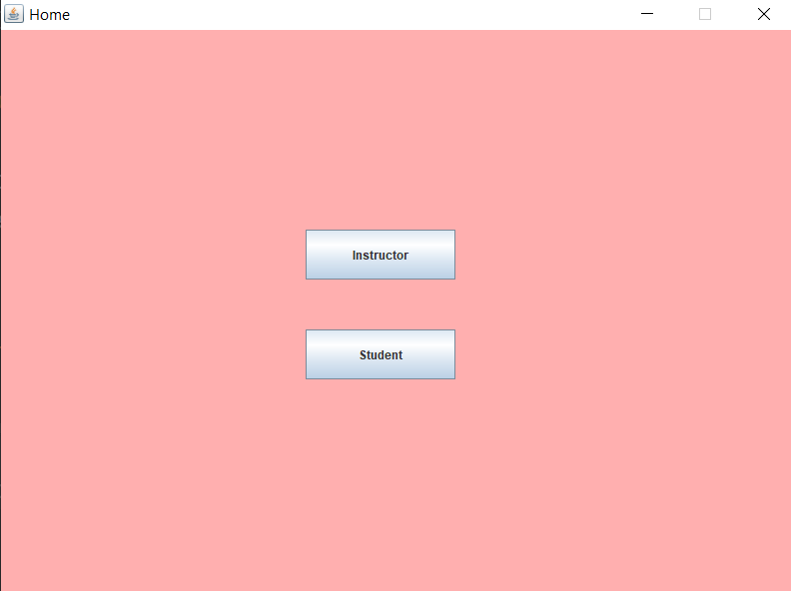Only screen have 2 buttons **student** to access student frame and **instructor** to access instructor frame.

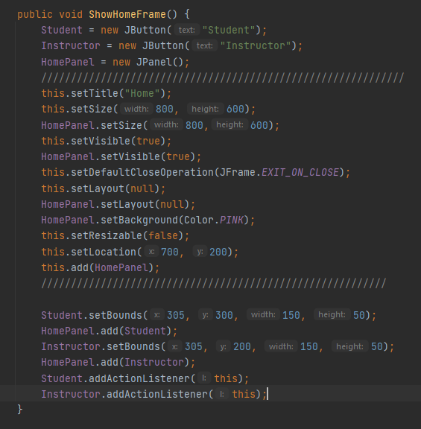**Code:**

**2-Instructor Frame:**

Screen contain all functions of instructor. Text box for writing id of student and click search.

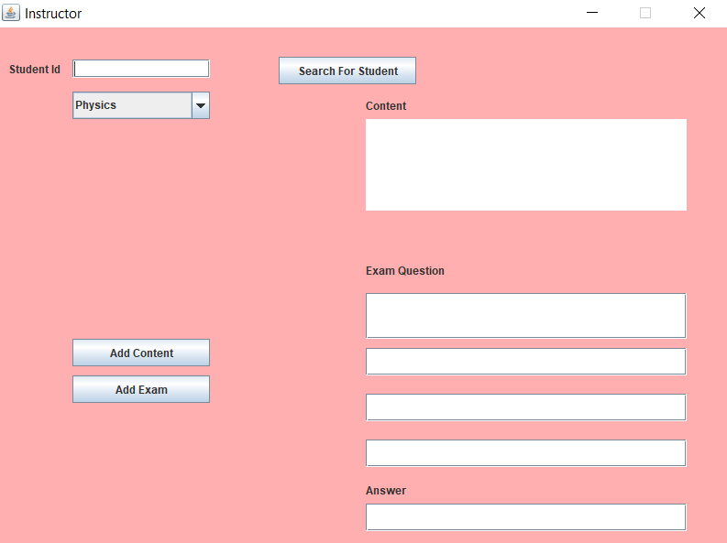Text area for adding content to the course. Five text boxes for adding question and 4 choices of it and the last text box is for the answer.

**Code**:

public void ShowInstructorFrame(String course1 ,String course2 , String course3 , String course4) {  
  
 ContentB3 = new JButton("Add Content");  
 ExamB3= new JButton("Add Exam");  
 SearchForStudent = new JButton("Search For Student");  
 StudentIdText = new JTextField();  
 Text = new JTextArea();  
 Exam = new JTextField();  
 c1 = new JTextField();  
 c2 = new JTextField();  
 c3 = new JTextField();  
 Answer= new JTextField();  
 StudentIdLabel = new JLabel("Student Id");  
 Content = new JLabel("Content");  
 Ex = new JLabel("Exam Question");  
 Ans = new JLabel("Answer");  
 InstructorPanel = new JPanel();  
 combo = new JComboBox();  
 /////////////////////////////////////////////////////////////  
 this.setTitle("Instructor");  
 this.setSize(800, 600);  
 InstructorPanel.setSize(800,600);  
 this.setVisible(true);  
 InstructorPanel.setVisible(true);  
 this.setDefaultCloseOperation(JFrame.*EXIT_ON_CLOSE*);  
 this.setLayout(null);  
 InstructorPanel.setLayout(null);  
 InstructorPanel.setBackground(Color.*PINK*);  
 this.setResizable(false);  
 this.setLocation(700, 200);  
 this.add(InstructorPanel);  
 //////////////////////////////////////////////////////////  
 StudentIdLabel.setBounds(10, 40, 100, 10);  
 InstructorPanel.add(StudentIdLabel);  
 StudentIdText.setBounds(80, 35, 150, 20);  
 InstructorPanel.add(StudentIdText);  
 SearchForStudent.setBounds(305, 32, 150, 30);  
 InstructorPanel.add(SearchForStudent);  
 combo.setBounds(80, 70, 150, 30);  
 combo.addItem(course1);  
 combo.addItem(course2);  
 combo.addItem(course3);   
 combo.addItem(course4);  
 InstructorPanel.add(combo);  
 ContentB3.setBounds(80, 340, 150, 30);  
 InstructorPanel.add(ContentB3);  
 ExamB3.setBounds(80, 380, 150, 30);  
 InstructorPanel.add(ExamB3);  
 Content.setBounds(400, 70, 350, 30);  
 InstructorPanel.add(Content);  
 Text.setBounds(400, 100, 350, 100);  
 InstructorPanel.add(Text);  
 Ex.setBounds(400, 250, 350, 30);  
 InstructorPanel.add(Ex);  
 Exam.setBounds(400, 290, 350, 50);  
 InstructorPanel.add(Exam);  
 c1.setBounds(400, 350, 350, 30);  
 InstructorPanel.add(c1);  
 c2.setBounds(400, 400, 350, 30);  
 InstructorPanel.add(c2);  
 c3.setBounds(400, 450, 350, 30);  
 InstructorPanel.add(c3);  
 Ans.setBounds(400, 490, 350, 30);  
 InstructorPanel.add(Ans);  
 Answer.setBounds(400, 520, 350, 30);  
 InstructorPanel.add(Answer);  
 SearchForStudent.addActionListener(this);  
 ContentB3.addActionListener(this);  
 ExamB3.addActionListener(this);  
}

**3-Student Frame:**

Firstly, student write his id and choose courses which he needs to register and click register. Then he can show the course content and click on exam and take the exam of the chosen course.

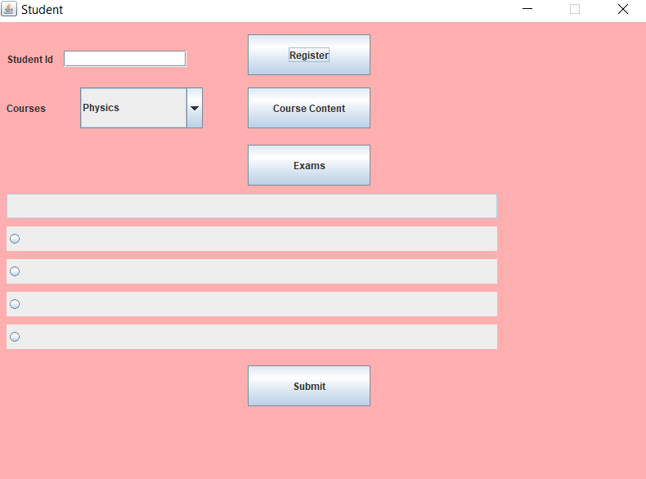

**Code:**

public void ShowStudentFrame(String course1 ,String course2 , String course3 , String course4) {  
 Submit =new JButton("Submit");  
 CourseContent = new JButton("Course Content");  
 Register =new JButton("Register");  
 StudentIdText2 = new JTextField();  
 Question = new JTextField();  
 Courses = new JLabel("Courses");  
 Exams = new JButton("Exams");  
 StudentIdLabel2 = new JLabel("Student Id");  
 combostd = new JComboBox();  
 StudentPanel = new JPanel();  
 C1 = new JRadioButton("");  
 C2 = new JRadioButton("");  
 C3 = new JRadioButton("");  
 C4 = new JRadioButton("");  
 choices = new ButtonGroup();  
 /////////////////////////////////////////////////////////////  
 this.setTitle("Student");  
 this.setSize(800, 600);  
 StudentPanel.setSize(800,600);  
 this.setVisible(true);  
 StudentPanel.setVisible(true);  
 this.setDefaultCloseOperation(JFrame.*EXIT_ON_CLOSE*);  
 this.setLayout(null);  
 StudentPanel.setLayout(null);  
 StudentPanel.setBackground(Color.*PINK*);  
 this.setResizable(false);  
 this.setLocation(700, 200);  
 this.add(StudentPanel);  
 //////////////////////////////////////////////////////////  
 StudentIdLabel2.setBounds(10, 40, 100, 10);  
 StudentPanel.add(StudentIdLabel2);  
 StudentIdText2.setBounds(80, 35, 150, 20);  
 StudentPanel.add(StudentIdText2);  
 Register.setBounds(305, 15, 150, 50);  
 StudentPanel.add(Register);  
 CourseContent.setBounds(305, 80, 150, 50);  
 StudentPanel.add(CourseContent);  
 Courses.setBounds(10, 80, 150, 50);  
 StudentPanel.add(Courses);  
 combostd.setBounds(100, 80, 150, 50);  
 combostd.addItem(course1);  
 combostd.addItem(course2);  
 combostd.addItem(course3);  
 combostd.addItem(course4);  
 StudentPanel.add(combostd);  
 Exams.setBounds(305, 150, 150, 50);  
 StudentPanel.add(Exams);  
 Question.setBounds(10, 210, 600, 30);  
 StudentPanel.add(Question);  
 Question.setEditable(false);  
 C1.setBounds(10, 250, 600, 30);  
 choices.add(C1);  
 StudentPanel.add(C1);  
 C2.setBounds(10, 290, 600, 30);  
 choices.add(C2);  
 StudentPanel.add(C2);  
 C3.setBounds(10, 330, 600, 30);  
 choices.add(C3);  
 StudentPanel.add(C3);  
 C4.setBounds(10, 370, 600, 30);  
 choices.add(C4);  
 StudentPanel.add(C4);  
 Submit.setBounds(305, 420, 150, 50);  
 StudentPanel.add(Submit);  
 Register.addActionListener(this);  
 Submit.addActionListener(this);  
 Exams.addActionListener(this);  
 CourseContent.addActionListener(this);  
}

**4-Student Information Frame:**

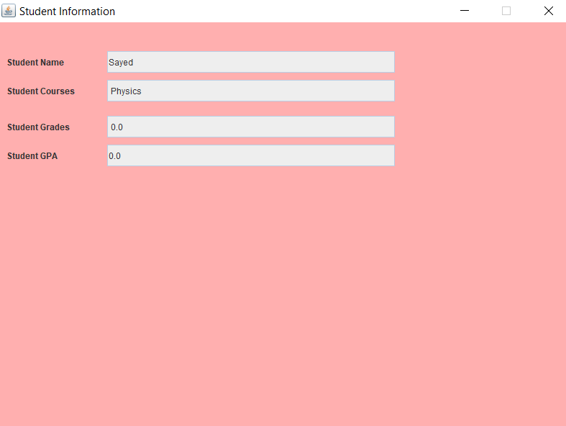When instructor type student id and then click show all information the frame will appear that contain all information about student.

**Code:**

public void ShowStudentInformation() {  
 StudentName = new JLabel("Student Name");  
 StudentCourse = new JLabel("Student Courses");  
 Studentgrade = new JLabel("Student Grades");  
 StudentGPA = new JLabel("Student GPA");  
 StudentNameT= new JTextField();  
 StudentCourseT= new JTextField();  
 StudentgradeT= new JTextField();  
 StudentGPAT= new JTextField();  
 StuInfoPanel = new JPanel();  
 StudentNameT.setEditable(false);  
 StudentCourseT.setEditable(false);  
 StudentgradeT.setEditable(false);  
 StudentGPAT.setEditable(false);  
 /////////////////////////////////////////////////////////////  
 this.setTitle("Student Information");  
 this.setSize(800, 600);  
 StuInfoPanel.setSize(800,600);  
 this.setVisible(true);  
 StuInfoPanel.setVisible(true);  
 this.setDefaultCloseOperation(JFrame.*EXIT_ON_CLOSE*);  
 this.setLayout(null);  
 StuInfoPanel.setLayout(null);  
 StuInfoPanel.setBackground(Color.*PINK*);  
 this.setResizable(false);  
 this.setLocation(700, 200);  
 this.add(StuInfoPanel);  
 //////////////////////////////////////////////////////////  
 StudentName.setBounds(10, 40, 100, 30);  
 StuInfoPanel.add(StudentName);  
 StudentCourse.setBounds(10, 80, 100, 30);  
 StuInfoPanel.add(StudentCourse);  
 Studentgrade.setBounds(10, 130, 100, 30);  
 StuInfoPanel.add(Studentgrade);  
 StudentGPA.setBounds(10, 170, 100, 30);  
 StuInfoPanel.add(StudentGPA);  
 StudentNameT.setBounds(150, 40, 400, 30);  
 StuInfoPanel.add(StudentNameT);  
 StudentCourseT.setBounds(150, 80, 400, 30);  
 StuInfoPanel.add(StudentCourseT);  
 StudentgradeT.setBounds(150, 130, 400, 30);  
 StuInfoPanel.add(StudentgradeT);  
 StudentGPAT.setBounds(150, 170, 400, 30);  
 StuInfoPanel.add(StudentGPAT);  
 *Ahmed*.GetStudentInfo(*flag*,Integer.*parseInt*(*stuId*),StudentNameT,StudentCourseT,StudentgradeT,StudentGPAT);  
  
}

**5-Show Content of course**

when student click on show content of course the frame will appear that contain all content

of course.

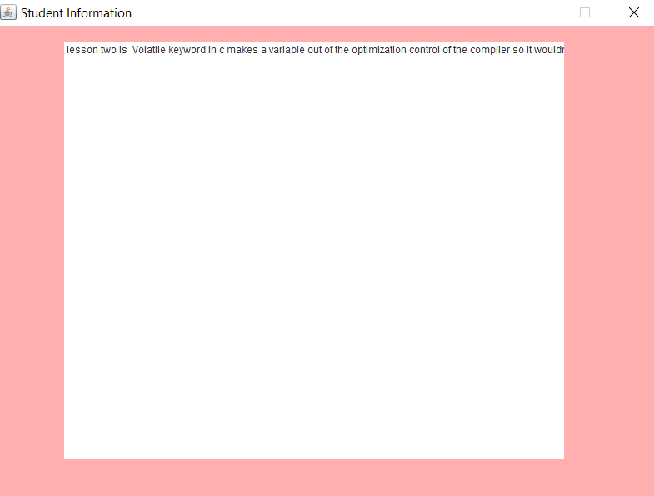

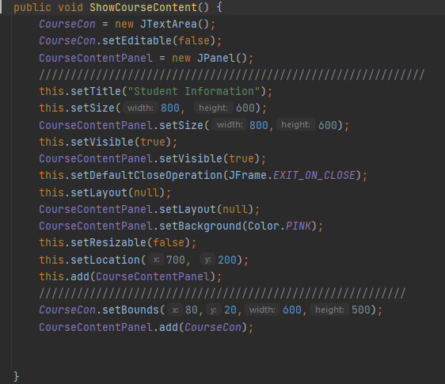**Code:**

**6-Instucor: Add Content:**

Function that makes instructor can add content of the course. It take 2 parameter course and contetn string.

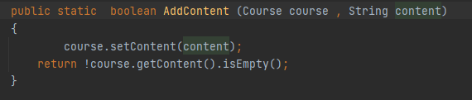

**7-Instucor: Add Exam:**

Function that makes instructor can add exam of the course. It take 2 parameter course and exam string.

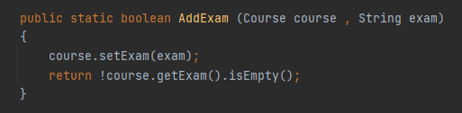

**8-Instucor: Show Student Info:**

Function that makes instructor can add show all information of student. It take 5 parameter Student and text fields will show them id , name, course, grade and GPA.

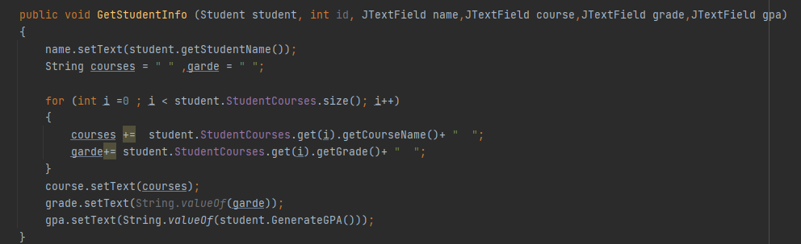

**9-Student: Registering Course:**

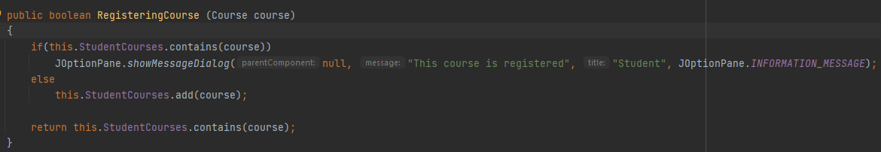Function that takes course as parameter and add it to array list of student registered courses.

Return true if added and false if there any problem.

**10-Student: Taking Exam:**

Function that takes course as parameter and grade of student in this course add it to array list of student registered courses. Return true if added and false if there any problem.

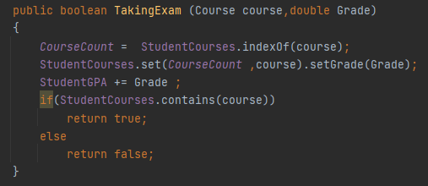

**Testing**

**1-Unit Testin :**

Using Junit, I tested 4 component of the system and it’s the 4 major function. These function is:

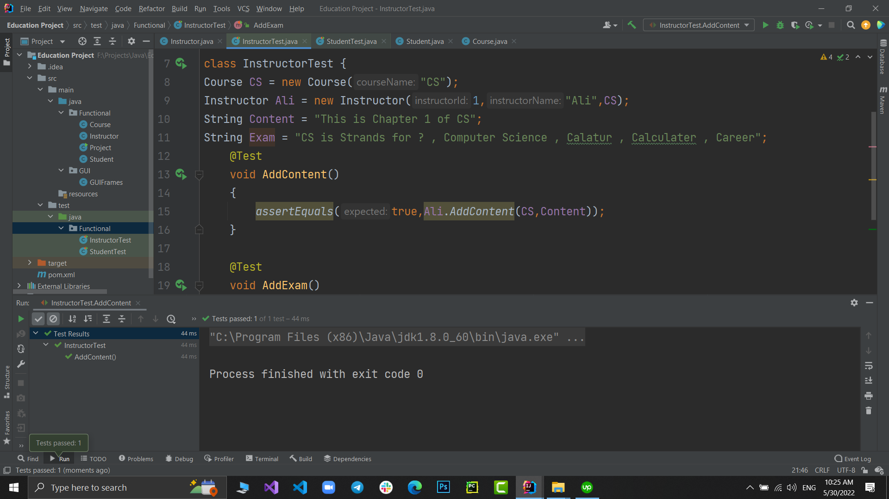 **1-Add Content:**

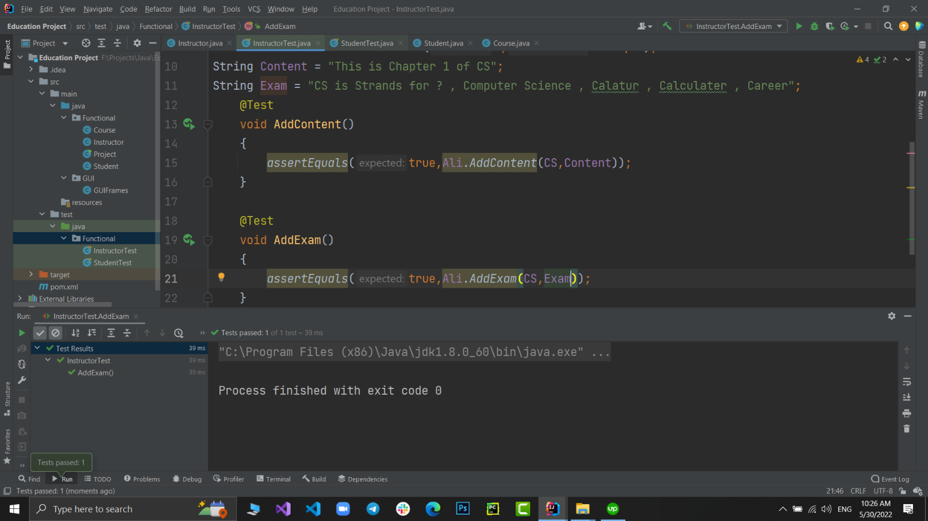 **2-Add Exam:**

**3-Registering Course:**

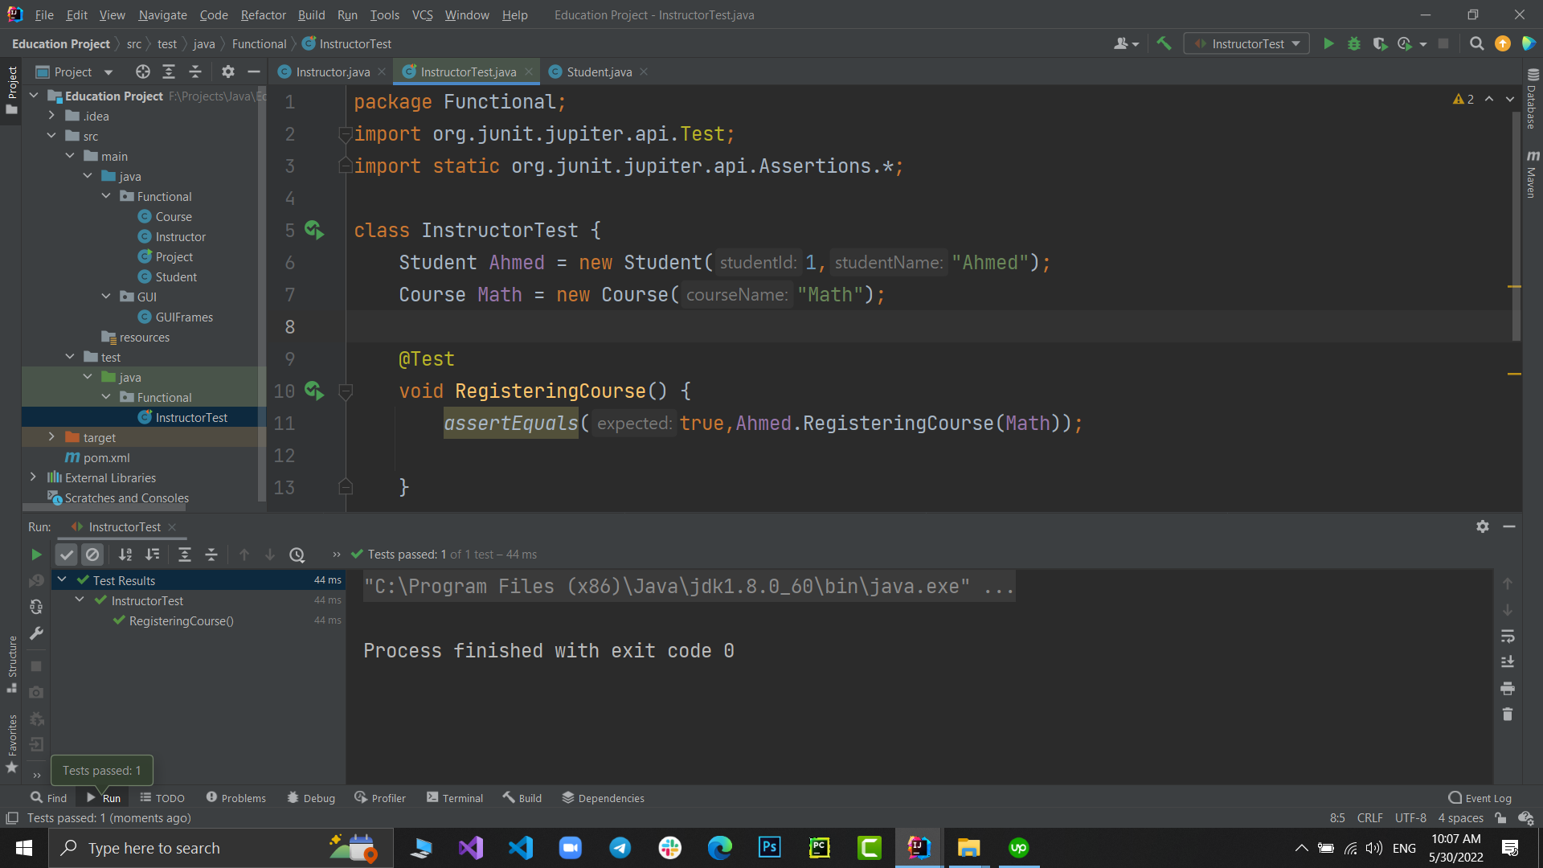

**4-Taking Exam:**

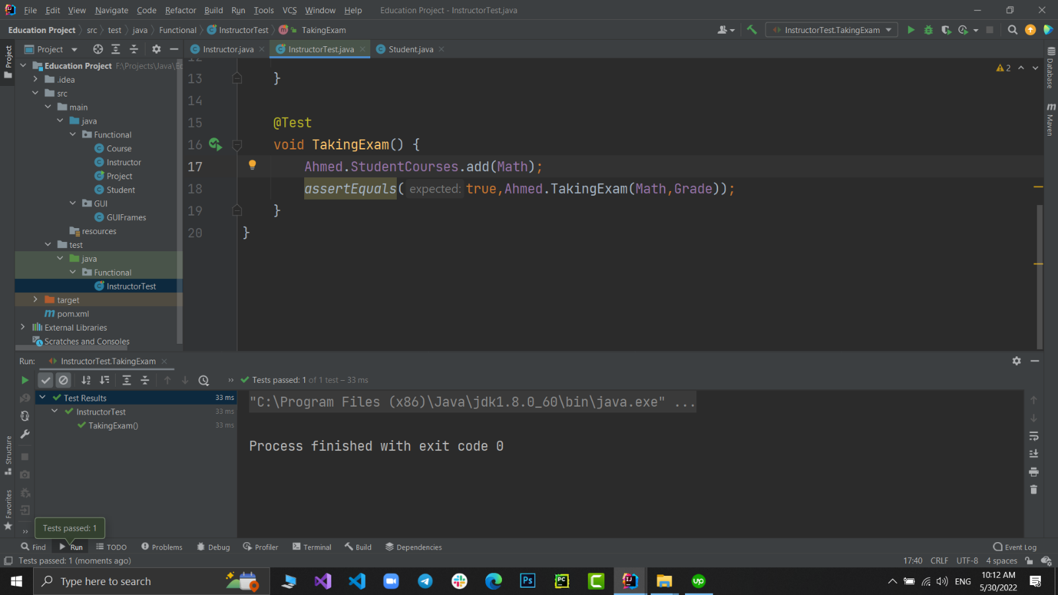

**2-GUI Testing:**

All fields are handled when its empty or contain wrong data. Follow the attachments in screenshots.

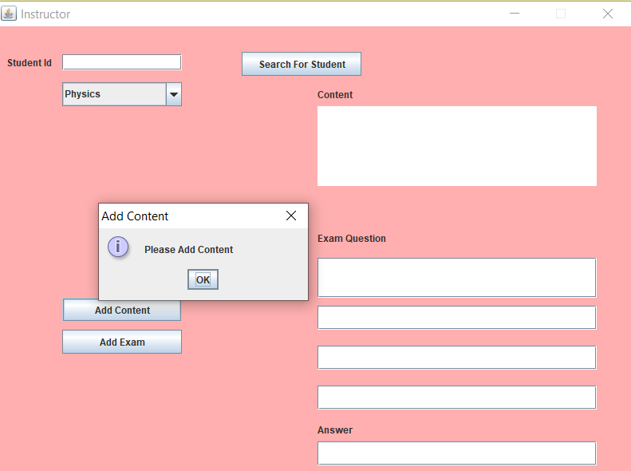

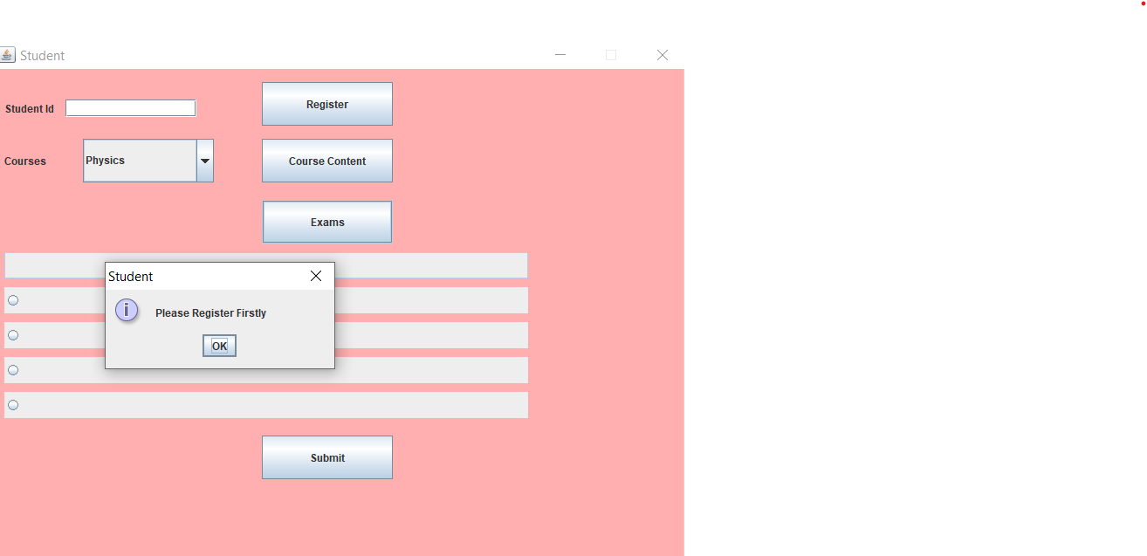

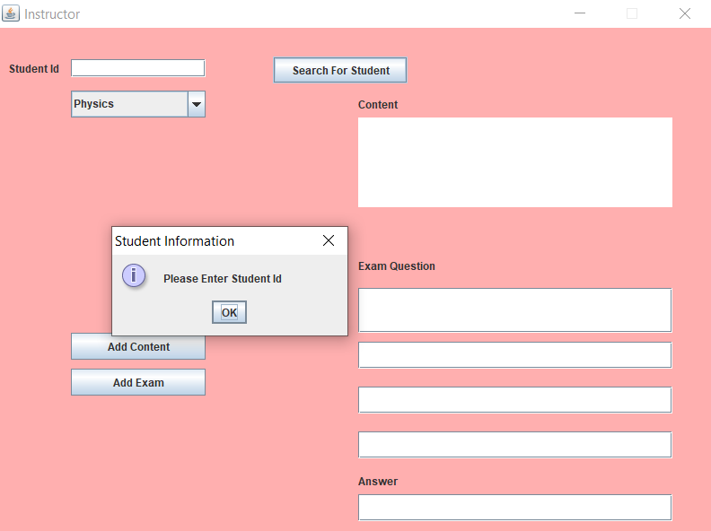

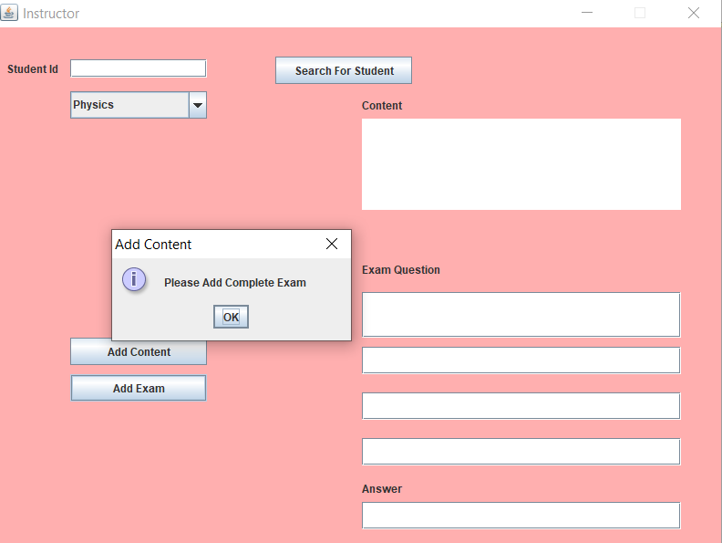

**3-Integration Testing:**

Integration is done manually using deferent scenarios. Follow the attachment for seeing some of them.

1-Register 2 courses by the student which his id is 1 and didn’t take the exam then show his info by instructor.

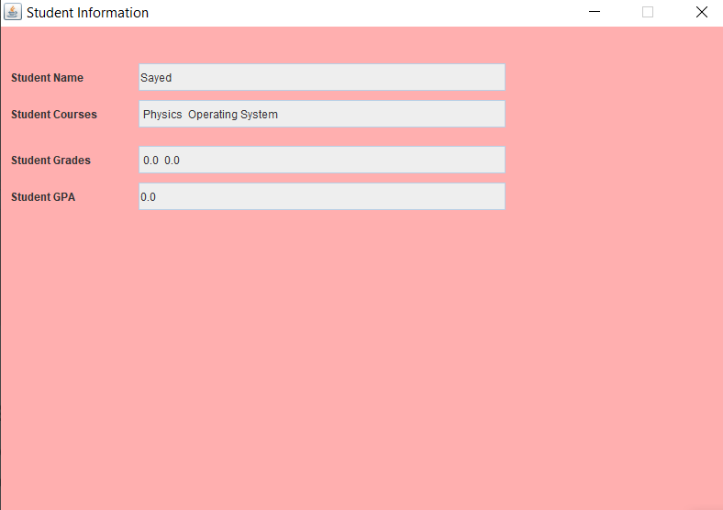

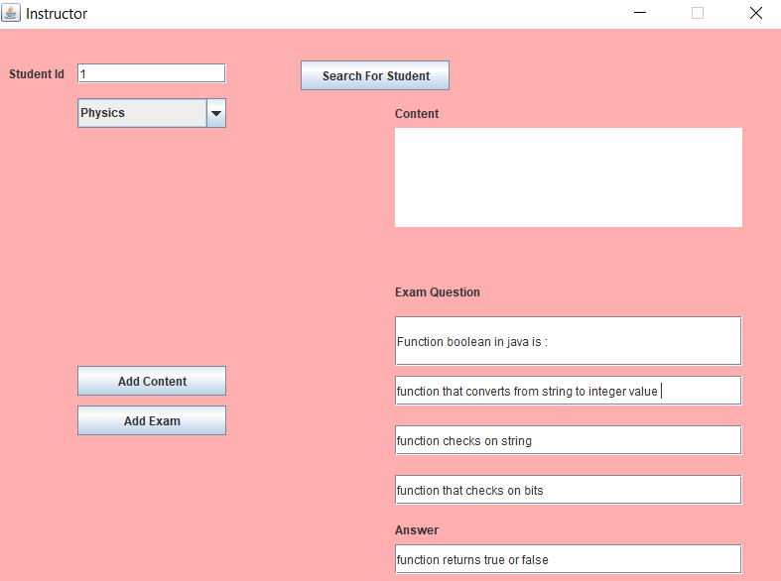2-Add exam for physics course by instructor and take it by student and test one positive test case with the really answer and one negative test case with the wrong answer follow the screenshots.

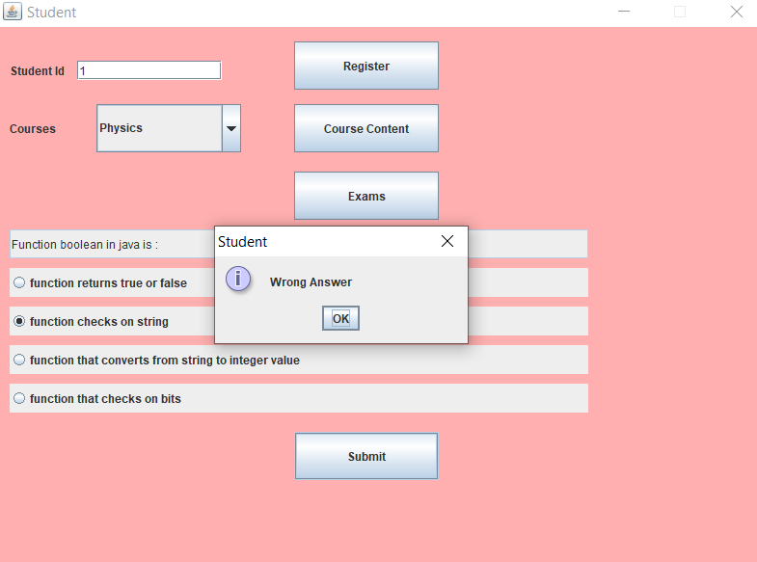**\*Negative Test Case:**

**\*Positive Test Case:**

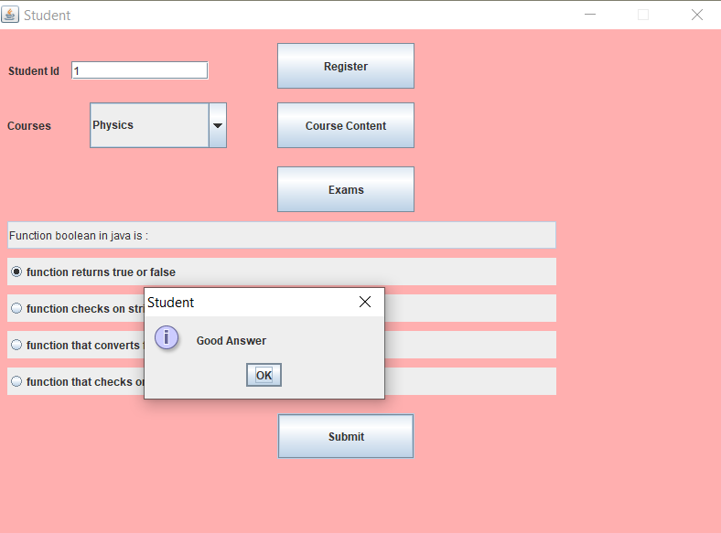

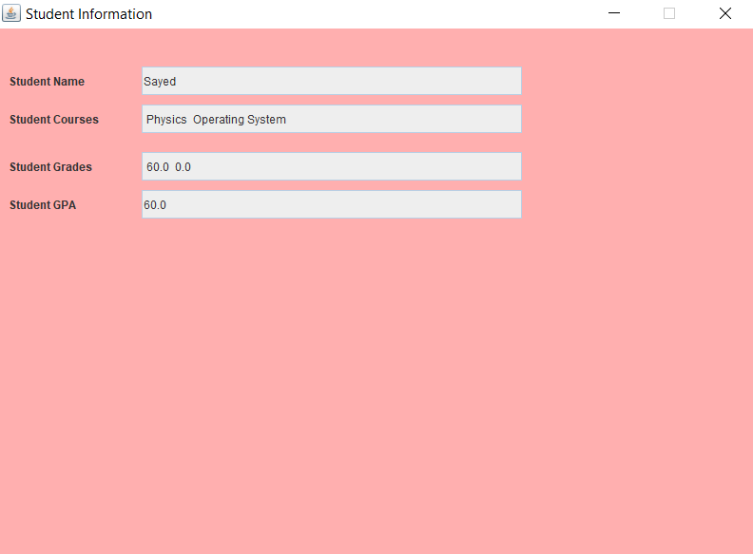Then if we go to see this student’s information by instructor, we will see it:

**Performance Testing:**

When you click to call any function there is alert will be visible show the time that function takes. Also, alert will show the average time when you call this function a lot of time.

* **Example: Instructor: Add Content**

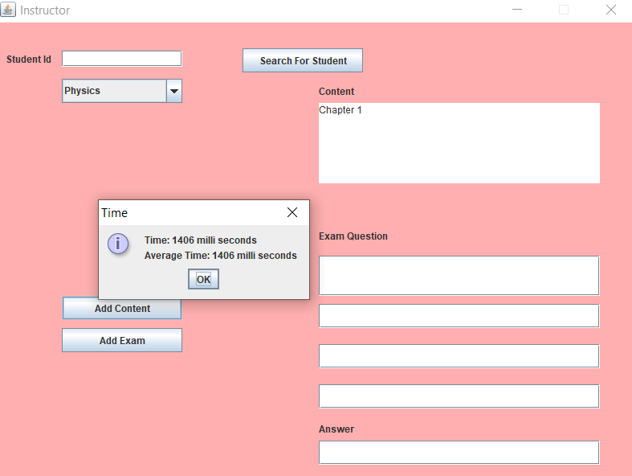After one call only:

After second call with a big amount of data:

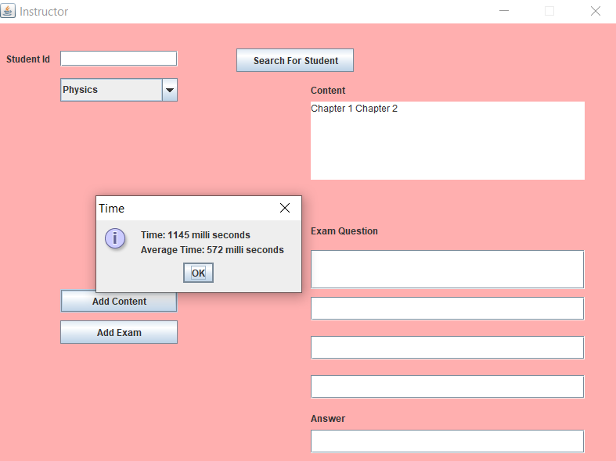

After third call with a big amount of data:

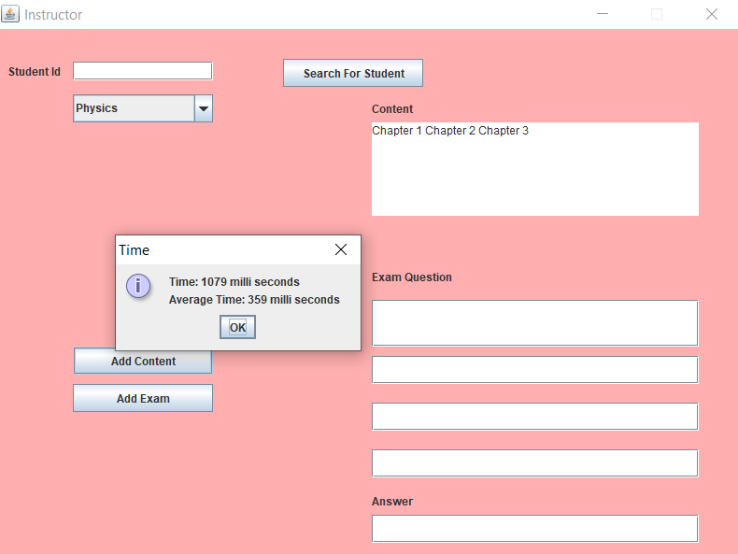

* **Example2: Instructor: Add Exam**

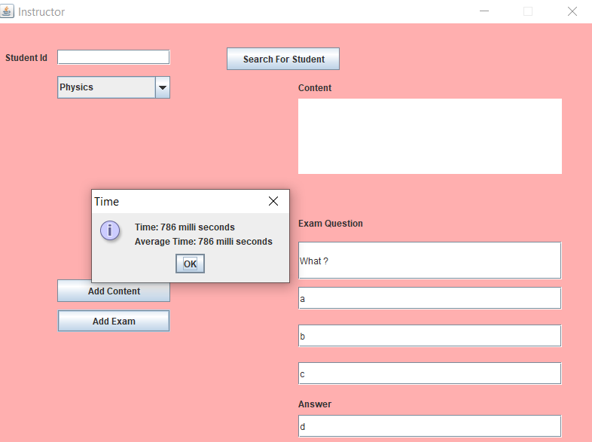After one call only:

After second call with a big amount of data:

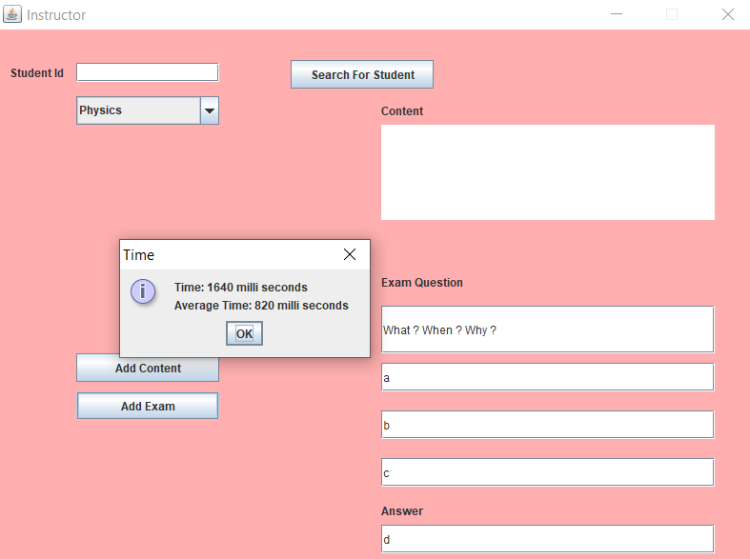

After third call with a big amount of data:

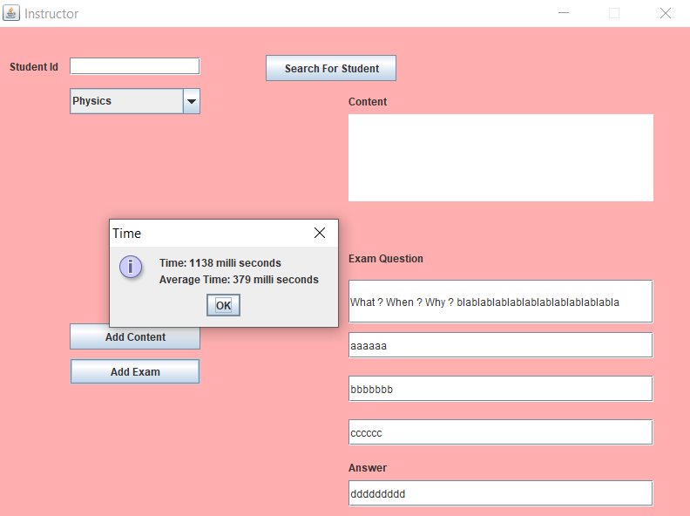

**Finally Follow Charts :**

* **Development Process**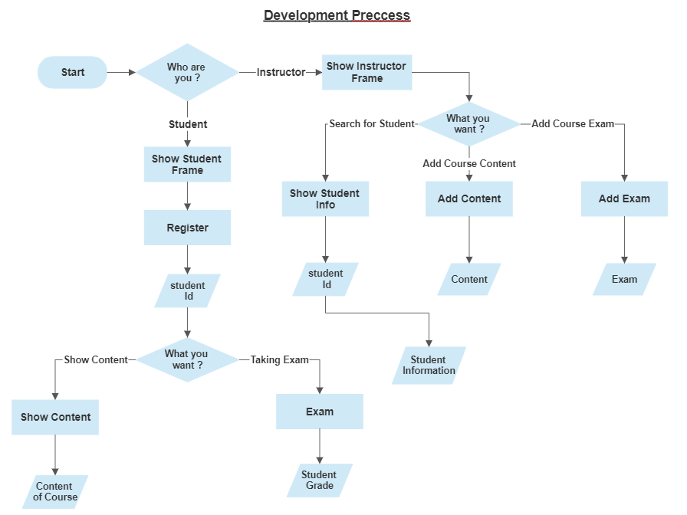
* **Integration Testing Process**

